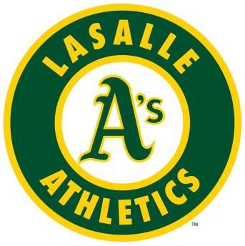
The success continues!
The LaSalle Athletics are pleased to announce the following tryouts for the 2017 competitive Fast Pitch / Softball season
Questions: Barry Yetman - Athletics VP – 519-817-4500 – byetman@cardinalcontracting.com
LASALLE ATHLETICS INTENDS TO FIELD MORE THAN ONE TEAM IN ALL DIVISIONS IF THERE IS ENOUGH INTEREST AT TRYOUTS
***PLEASE ARRIVE 15 MINS AHEAD OF THE POSTED TIME TO REGISTER ***
- - 2008 Mite
Saturday Sept 10th 9:00 am – 11:00 am - Turtle Club Diamonds #5 & 6
Sunday Sept 11th 9:00 am – 11:00 am - Turtle Club Diamonds #5 & 6
- - 2006 Squirt
Saturday Sept 10th 9:00 am – 11:00 am - Turtle Club Diamonds #3 & 4
Sunday Sept 11th 4:00 pm – 6:00 pm - Turtle Club Diamonds #3 & 4
2003 - 2004 Novice
Saturday Sept 10th 6:00 pm – 8:00 pm - Turtle Club Diamonds #3 & 4
Sunday Sept 11th 6:00 pm – 8:00 pm - Turtle Club Diamonds #3 & 4
- - 2002 Bantam
Monday Sept 12th 6:00 pm – 8:00 pm - Turtle Club Diamonds #3 & 4
Friday Sept 16th 6:00 pm – 8:00 pm - Turtle Club Diamonds #3 & 4
- - 2000 Midget
Saturday Sept 10th 11:00 am – 1:00 pm - Turtle Club Diamond #3
Sunday Sept 11th 11:00 pm – 1:00 pm - Turtle Club Diamond #3

All tryouts will take place at Turtle Club Park Please check our website for additional information.
WWW.TURTLECLUBBASEBALL.COM

